**Data Security and Privacy in Big Data Analysis Using IBM Cloud Databases**

|  |  |
| --- | --- |
| **Date** | **01-11-2023** |
| **Team ID** | **4190** |
| **Project Name** | **Data Security and Privacy in Big Data Analysis Using IBM Cloud Databases** |

**Table of Contents**

|  |  |
| --- | --- |
| **S.No** | **CONTENTS** |
| 1 | Introduction |
| 2 | Problem Statement |
| 3 | Literature Survey |
| 4 | Design Thinking |
| 5 | Description of Developed phases |
| 5.1 | Algorithm Techniques |
| 5.2 | Platform Implemented |
| 5.3 | Code for the Project |
| 6 | Conclusion |

**1. Introduction**

In the era of data abundance, organizations are accumulating massive datasets across diverse domains, presenting both opportunities and challenges. IBM Cloud Databases offer a robust platform for Big Data analysis, promising the discovery of valuable insights and data-driven adventures. And this project aims to utilize innovative approaches to enhance prediction accuracy and reliability.

In the dynamic landscape of big data analysis utilizing IBM Cloud databases, the dual imperatives of data security and privacy play a pivotal role in shaping a trustworthy and resilient framework. With an unprecedented influx of data characterized by its vast volume, velocity, and variety, IBM Cloud databases stand as a foundational element in the storage and processing of this wealth of information. Robust security infrastructure, encompassing encryption protocols, stringent access controls, and authentication mechanisms, forms a formidable defense against evolving cyber threats. Moreover, the imperative adherence to data privacy regulations, such as GDPR and HIPAA, is seamlessly facilitated by IBM Cloud databases, ensuring compliance and safeguarding individual privacy rights. The integration of advanced auditing and monitoring tools further contributes to the proactive identification of anomalies and potential breaches. Despite the scale and complexity inherent in big data environments, IBM Cloud's scalable solutions address these challenges cohesively, fostering an environment where cutting-edge analytics and unwavering security measures coalesce. In conclusion, the marriage of advanced analytics with stringent security measures in IBM Cloud databases establishes a foundation for organizations to embark on data-driven journeys, confident in the integrity, confidentiality, and privacy of their data.

**2. Problem Statement**

The project involves delving into big data analysis using IBM Cloud Databases. The objective is to extract valuable insights from extensive datasets, ranging from climate trends to social patterns. The project includes designing the analysis process, setting up IBM Cloud Databases, performing data analysis, and visualizing the results for business intelligence.

Ensure the highest level of data security and privacy in Big Data analysis conducted within the IBM Cloud database environment. Big Data analytics offers valuable insights, but the handling of sensitive data introduces significant security and privacy challenges.

**Data Used**

Organizations are increasingly relying on Big Data analytics to extract actionable insights from large and diverse datasets. This process often involves the use of cloud databases, such as those offered by IBM, to store and analyze vast amounts of data. However, this presents a range of security and privacy concerns, including data breaches, unauthorized access, and compliance with data protection regulations (e.g., GDPR, HIPAA).

**3. Literature survey**

**1. “Big data with cloud computing: discussions and challenges”- Amanpreet Kaur Sandhu [2022]**

With the recent advancements in computer technologies, the amount of data available is increasing day by day. However, excessive amounts of data create great challenges for users. Meanwhile, cloud computing services provide a powerful environment to store large volumes of data. They eliminate various requirements, such as dedicated space and maintenance of expensive computer hardware and software. Handling big data is a time-consuming task that requires large computational clusters to ensure successful data storage and processing. In this work, the definition, classification, and characteristics of big data are discussed, along with various cloud services, such as Microsoft Azure, Google Cloud, Amazon Web Services, International Business Machine cloud, Hortonworks, and mapr. A comparative analysis of various cloud-based big data frameworks is also performed. Various research challenges are defined in terms of distributed database storage, data security, heterogeneity, and data visualization.

**2. “A cloud-enabled collaborative hub for analysis of geospatial big data” –Xingqiang Du,Wei Wan[2021]**

Geospatial big data are analyzed for addressing a specific research or management problem on global scale, and science gateways or Hub, have been widely adopted in recent years as an effective platform for an entry to computational resources, research collaboration, dissemination of data, applications and publications, and community engagement. However, replicating deployment and setup is a non-trivial task. Cloud computing provides an attractive alternative, simplifying resource provision and enabling reliable and scalable replication. This paper describes ongoing efforts to a cloud-enabled Geospatial Hub hosting general-purpose software building blocks, which provides geospatial data access, processing, analysis, and visualization capabilities. The technologies underlying these components, the automation of deployment and configuration on cloud with the Elastic Compute Service (ECS) and Object Storage Service (OBS) are described. This work builds geospatial big data analysis capabilities into web-based Hub platform and empower it by cloud computing. This will open a way for easy development of a variety of online tools for probing and presenting geospatial big data and digital information.

**3. “Cloud transformative involvement in managing big data analytics for securing data in transist storage and uses”- Harmaninder Jit Singh Sidhu, Maninderjit Singh Khanna [2021]**

The aim of this paper is to the advent of Cloud Computing in a new era of computing has come into existence. No doubt, there are numerous advantages associated with the Cloud Computing but, there is other side of the picture too. The challenges associated with it need a more promising reply as far as the security of data that is stored, in process and in transit is concerned. This paper put forth a cloud computing model that tries to answer the data security queries; we are talking about, in terms of the four cryptographic techniques namely Homomorphic Encryption (HE), Verifiable Computation (VC), Secure Multi-Party Computation (SMPC), Functional Encryption (FE). This paper takes into account the various cryptographic techniques to undertake cloud computing security issues. It also surveys these important (existing) cryptographic tools/techniques through a proposed Cloud computation model that can be used for Big Data applications. Further, these cryptographic tools are also taken into account in terms of CIA triad. Then, these tools/techniques are analyzed by comparing them on the basis of certain parameters of concern.

**4. “GIS cloud computing-based government big data analysis platform”- Qiang Wang, Yanyuan Jiang [2021]**

This aims to show the Transparency, wisdom and responsibility are new requirements for government work in the era of Big Data. Government Big Data is changing the traditional mode of government work, which needs corresponding technical means for auxiliary analysis and application. This paper first analyzes the spatial related government Big Data, then introduces association analysis method of government Big Data, based on GIS cloud computing technology, it proposes the government Big Data platform architecture and main functions, and finally explores the application analysis case based on traffic accident data. The design thinking process is a problem-solving approach that focuses on understanding the needs and perspectives of users in order to create innovative solutions.

**5.** **“Protecting big data in public cloud by enhanced RBAC”- J.L.Joneston Dhas,S.Maria Celestein Vigila [2020]**

The enterprise systems which runs in the public cloud environment are beyond the control of the users. However, the traditional access control methods which will be executed by the reference monitors on cloud server will not be trusted in future. In this paper a security scheme is proposed and which protects the enterprise system called E_RBAC. The decryption and access control are enforced by CPABE and the authentication are done in the data. The experimental result shows the E_RBAC maintains efficiency, security of the data and the access control will get improved.

**4. Design thinking**

1. **Empathize:**

Gain a deep understanding of the users and their needs by conducting research, interviews, and observations. Before diving into solving the problem, it's crucial to empathize with the users and understand their needs like Understanding the concerns and priorities of stakeholders, including data owners, compliance officers, and end-users, Identify potential security and privacy risks associated with Big Data analysis and Conduct interviews, surveys, and workshops to gather insights into data security and privacy needs.

**Some of the empathize techniques includes:**

1.Security Framework Development

2.Continuous Monitoring and Auditing

3.Stakeholder Training and Feedback

**2.Define:**

Clearly define the problem statement based on the insights gathered during the empathize stage. Based on our understanding of the problem and the users' needs, we will define clear objectives and success criteria for our project.

Compliance Checklist: Create a compliance checklist outlining the key regulatory requirements you must adhere to, such as GDPR, HIPAA, or industry-specific standards.

**Objectives:**

**1.Ensure Data Confidentiality and Compliance:**

The primary objective is to establish a robust security framework that safeguards data confidentiality and integrity throughout the Big Data analysis process, ensuring compliance with relevant regulations (e.g. GDPR, HIPAA).

**2.Mitigate Security Risks and Vulnerabilities:**

Proactively identify, assess, and mitigate security risks and vulnerabilities in the IBM Cloud Database environment, enabling secure data analysis and protection against data breaches and cyber threats.

**3.Ideate:** Generate a wide range of ideas and potential solutions to address the defined problem. Brainstorm creative solutions and strategies for data security and privacy.

-Explore encryption techniques for data at rest and in transit.

-Consider access control mechanisms, user authentication, and authorization protocols and Evaluate options for data anonymization and masking.

-Identify tools and technologies for monitoring and auditing data access and activities.

**4.Prototype:**

Create tangible representations of the ideas generated in the ideation stage to test and gather feedback.

Develop a prototype of the security framework, implementing encryption, access controls, and data anonymization within the IBM Cloud Database environment.

Develop Security Prototypes: Create prototypes of security measures, including encryption, access controls, and monitoring configurations within a controlled environment for testing.

-**Implement Security Dashboards:** Develop user-friendly security dashboards or interfaces that provide real-time visibility into data access, security events, and compliance status.

-**Conduct Security Testing:** Test the security prototypes and interfaces using simulated scenarios and penetration testing to validate their effectiveness and identify vulnerabilities.

**5.Test:**

Test the prototypes with users to gather feedback and refine the solutions. Security Testing: Perform penetration testing and vulnerability assessments to identify and remediate security vulnerabilities.

-Compliance Validation: Conduct security and privacy assessments to validate compliance with relevant regulations.

-User Feedback: Gather feedback from stakeholders and end-users regarding the usability and effectiveness of the security and privacy features.

-Data Segmentation: Segregate sensitive and non-sensitive data within the database to create controlled access segments for secure analysis.

-Security Assessment: Conduct comprehensive security assessments, including penetration testing and vulnerability scanning, to evaluate the effectiveness of security measures.

-Compliance Validation: Perform compliance validation assessments to ensure that security controls align with regulatory requirements and industry standards.

-User Training and Awareness: Provide training to users and stakeholders on data security protocols and best practices, emphasizing the importance of data privacy.

**6.Iterate**:

Based on the feedback received, make necessary improvements and iterate on the design.

The design thinking process is iterative and encourages collaboration, creativity, and a user-centered approach to problem-solving.

Continuous Monitoring: Continuously monitor and assess the effectiveness of data security and privacy measures to identify and respond to emerging threats.

-Regulatory Updates: Stay informed about evolving security threats and privacy regulations, and update the security framework as needed.

-Regular Audits: Conduct regular security and privacy audits to ensure ongoing compliance and address any issues that arise.

-Continuous Security Monitoring and Updates: Continuously monitor the data security framework's performance and effectiveness. Regularly review and update security measures to adapt to evolving threats and vulnerabilities.

-User Feedback and Enhancements: Solicit feedback from users and stakeholders regarding the security measures and their usability. Use this feedback to make necessary improvements to security protocols and interfaces.

-Security Awareness and Training: Conduct regular training sessions and awareness programs for personnel to keep them informed about the latest security best practices and emerging threats.

-Threat Intelligence Integration: Stay informed about advancements in the field of data security, threat intelligence, and privacy regulations. Integrate new security technologies and practices as needed to enhance protection

**Steps for the Analysis:**

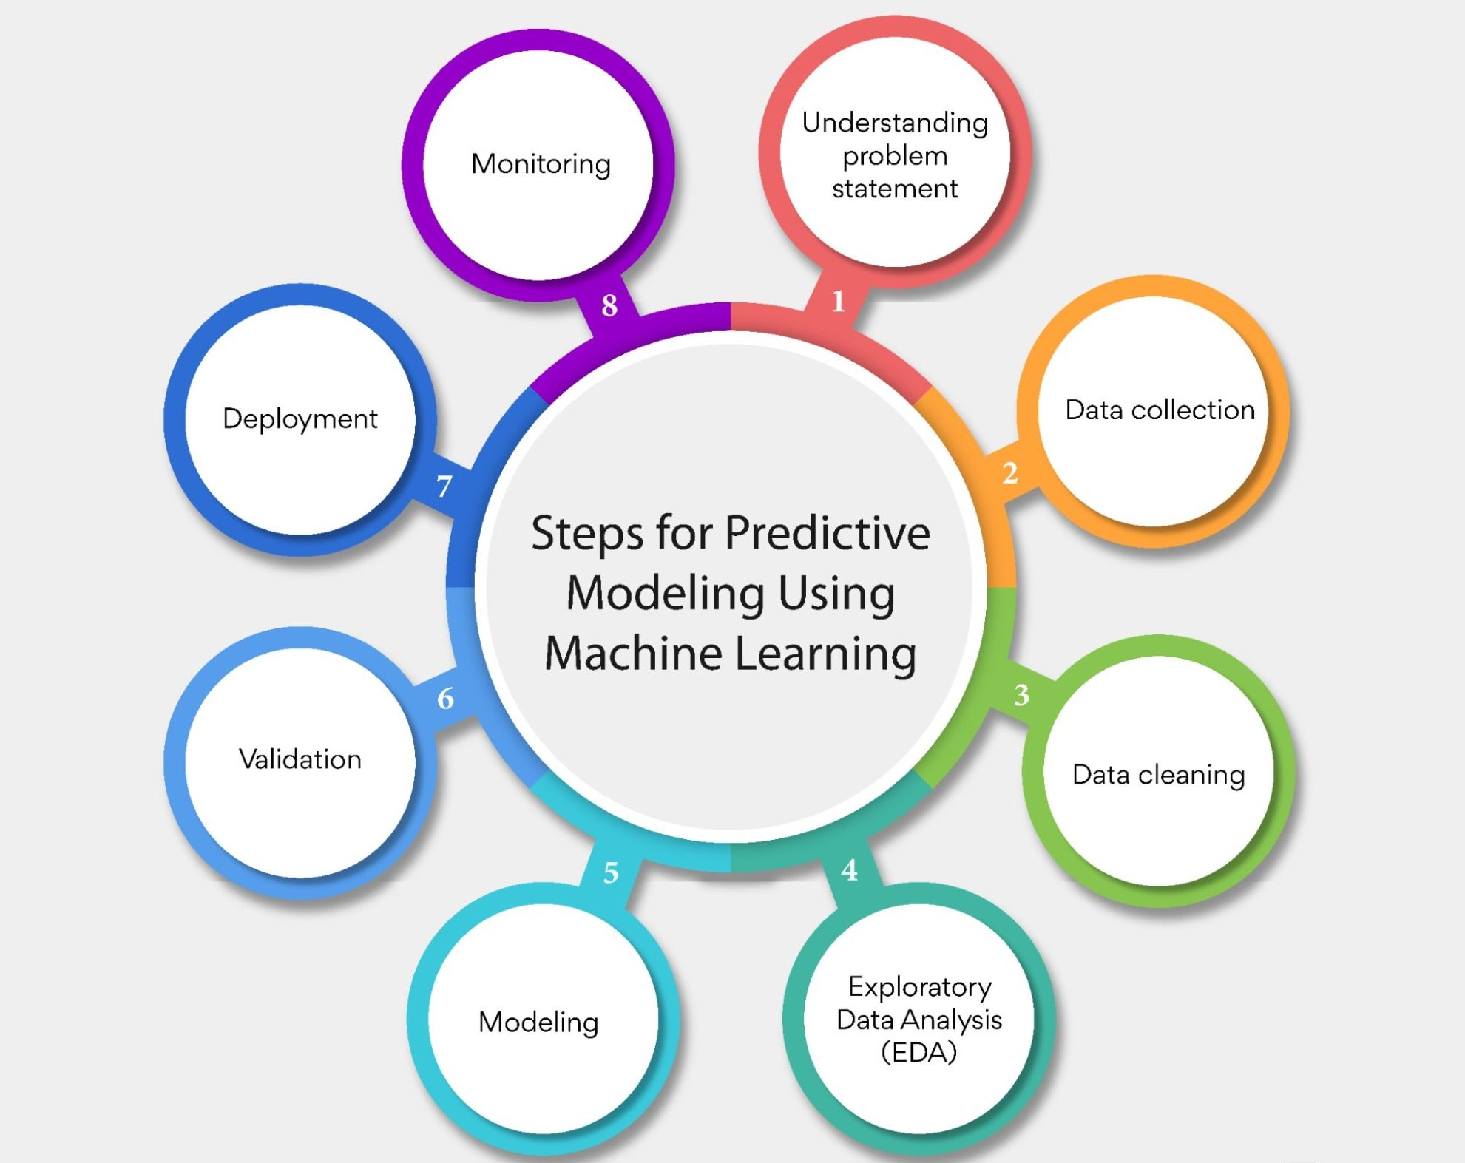

**FLOWCHART:**

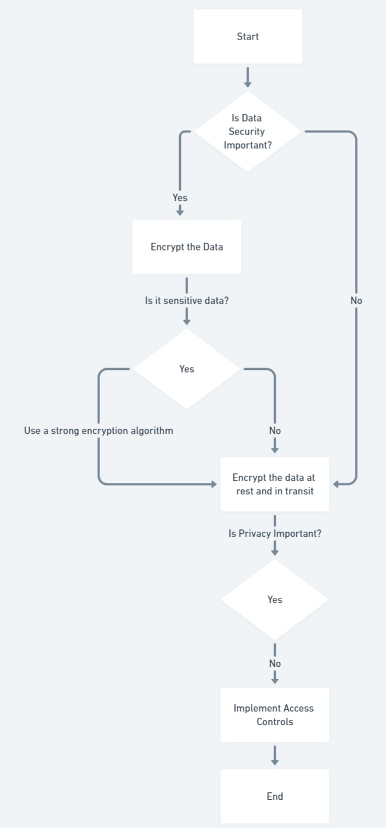

**5. Description of Development Phases**

**5.1 Algorithm Techniques:**

**Time Series Analysis with ARIMA or Exponential Smoothing:**

Time series analysis is crucial for understanding and forecasting demand patterns over time. ARIMA (autoregressive Integrated Moving Average) and Exponential Smoothing models are widely used for this purpose.

**Machine Learning Regression Models:**

Regression models, such as linear regression or advanced algorithms like xgboost, can capture complex relationships between demand and various features like time, promotions, or external factors.

**Deep Learning with Recurrent Neural Networks (rnns) or Long Short-Term Memory (LSTM) Networks**:

Deep learning models, particularly rnns and lstms, are effective for capturing sequential dependencies in time series data. They can learn patterns in demand with a focus on long-term dependencies.

**Customer Reviews and Sentiment Analysis:**

Analyzing customer reviews and sentiments provides insights into how consumer perception impacts demand. Sentiment analysis, using natural language processing (NLP), helps understand the qualitative factors affecting product demand.

**Ensemble Models for Robust Predictions:**

Combining the predictions of multiple models using ensemble techniques (e.g., stacking, blending) can enhance predictive accuracy. Ensemble models are particularly useful when different models capture different aspects of demand patterns.

These techniques, when applied judiciously, can provide a comprehensive understanding of historical product demand, enabling more accurate forecasting and better-informed decision-making. Keep in mind that the choice of technique depends on the characteristics of your dataset and the specific goals of your analysis.

**Time Series Analysis:**

The journey begins with rigorous data preprocessing to address missing values, outliers, and enhance data quality. Exploratory Data Analysis (EDA) reveals temporal patterns, seasonality, and trends. Depending on the nature of the data, temporal aggregation is applied to achieve the desired granularity. A judicious choice of time series models, ranging from ARIMA to advanced models like Prophet, is made to accurately forecast demand. Model validation is conducted through robust evaluation metrics on training and testing datasets.

Harmonizing advanced time series analysis with stringent data security and privacy measures is imperative for extracting meaningful insights from historical product demand data on IBM Cloud. This integrated approach safeguards sensitive information, fosters compliance, and enhances the ethicality of data analysis practices.

**Holt-Winters Exponential Smoothing method:**

In Historical product demand analysis, the Holt-Winters Exponential Smoothing method offers a robust approach for time series forecasting. This delves into the application of this technique while prioritizing data security and privacy within the realm of big data analysis using IBM Cloud datasets.

**Holt-Winters Exponential Smoothing:** Holt-Winters is a time series forecasting method that captures trends, seasonality, and level components. It provides a powerful tool for predicting future values based on historical data patterns.

**Data Security and Privacy Measures:**

**Encryption Protocols:** Implement end-to-end encryption protocols for data in transit and at rest within the IBM Cloud, safeguarding historical demand data against unauthorized access.

**Access Controls and RBAC**: Enforce strict access controls and Role-Based Access Control (RBAC) mechanisms, ensuring that only authorized personnel have access to the historical demand dataset.

**Anonymization Techniques:** Apply anonymization techniques to shield personally identifiable information (PII) in the historical demand dataset, aligning with data privacy regulations and safeguarding customer identities.

**Secure Data Transmission:** Utilize secure data transmission protocols, such as HTTPS, to protect historical demand data during transit between cloud components and external entities.

**Implementation Steps for Holt-Winters Exponential Smoothing:**

**Data Preprocessing:** Conduct thorough data preprocessing, handling missing values and outliers, and ensuring the quality of the historical demand dataset.

**Exploratory Data Analysis (EDA):** Perform EDA to gain insights into temporal patterns, seasonality, and trends within the historical demand data.

**Temporal Aggregation:** Choose an appropriate temporal aggregation level based on the nature of the data, aligning with the desired analysis granularity (e.g., daily, weekly, monthly).

**Model Selection and Validation:** Select the Holt-Winters Exponential Smoothing model, considering the seasonality and trend components. Validate the model's performance using training and testing datasets.

**Secure Deployment on IBM Cloud:**

**Fortified Cloud Environment:** Configure a secure cloud environment on IBM Cloud with robust firewalls, continuous monitoring, and auditing capabilities to detect and respond to security incidents.

**Tokenization for Sensitive Data:** Employ tokenization methods for preserving the utility of sensitive data elements while maintaining their confidentiality.

**Monitoring and Ethical Considerations:**

**Real-time Monitoring:** Implement real-time monitoring mechanisms to promptly identify anomalies during the time series analysis, enhancing security incident response.

**Ethical Communication:** Transparently communicate with stakeholders about the purpose, methodology, and ethical considerations of time series analysis, fostering trust and compliance.The application of Holt-Winters Exponential Smoothing in historical product demand analysis on IBM Cloud is a powerful technique when coupled with stringent data security and privacy measures. This integrated approach ensures the extraction of meaningful insights while respecting privacy regulations and maintaining the confidentiality of sensitive information.

**5.2 Platform Implemented:**

**Local Machine:** Python code on your personal computer or server by installing Python. This is the most common way to execute Python scripts.

**Google colab:** Google colab which provides an interactive environment for running python code which is widely used by the industry experts.

**Jupyter Notebooks**: Jupyter Notebooks provide an interactive and web-based environment for running Python code. They are widely used for data analysis, visualization, and machine learning.

**Integrated Development Environments (ides):** Python code can be written and executed in various ides such as Visual Studio Code, pycharm, Spyder, and others. These environments provide features like code highlighting, debugging, and project management.

**Cloud Platforms:** Used IBM cloud platform for the selection of the appropriate database services like DB2 instance, Cloudant, Cloud Object Storage, Watson studio.

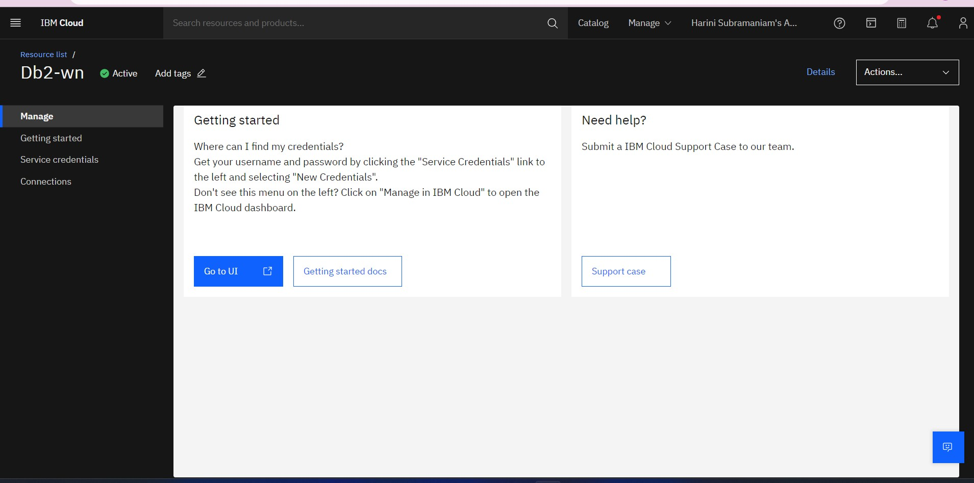

**IBM Cloudant**

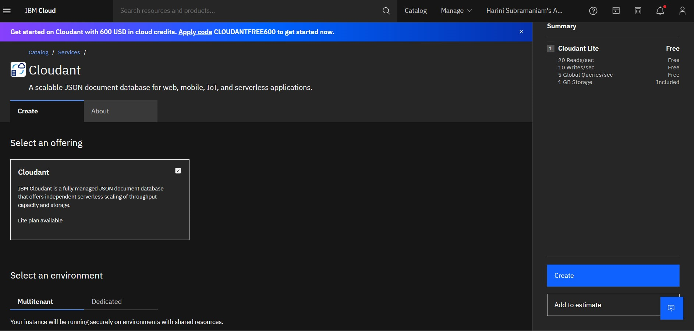

**Watson Machine Learning**

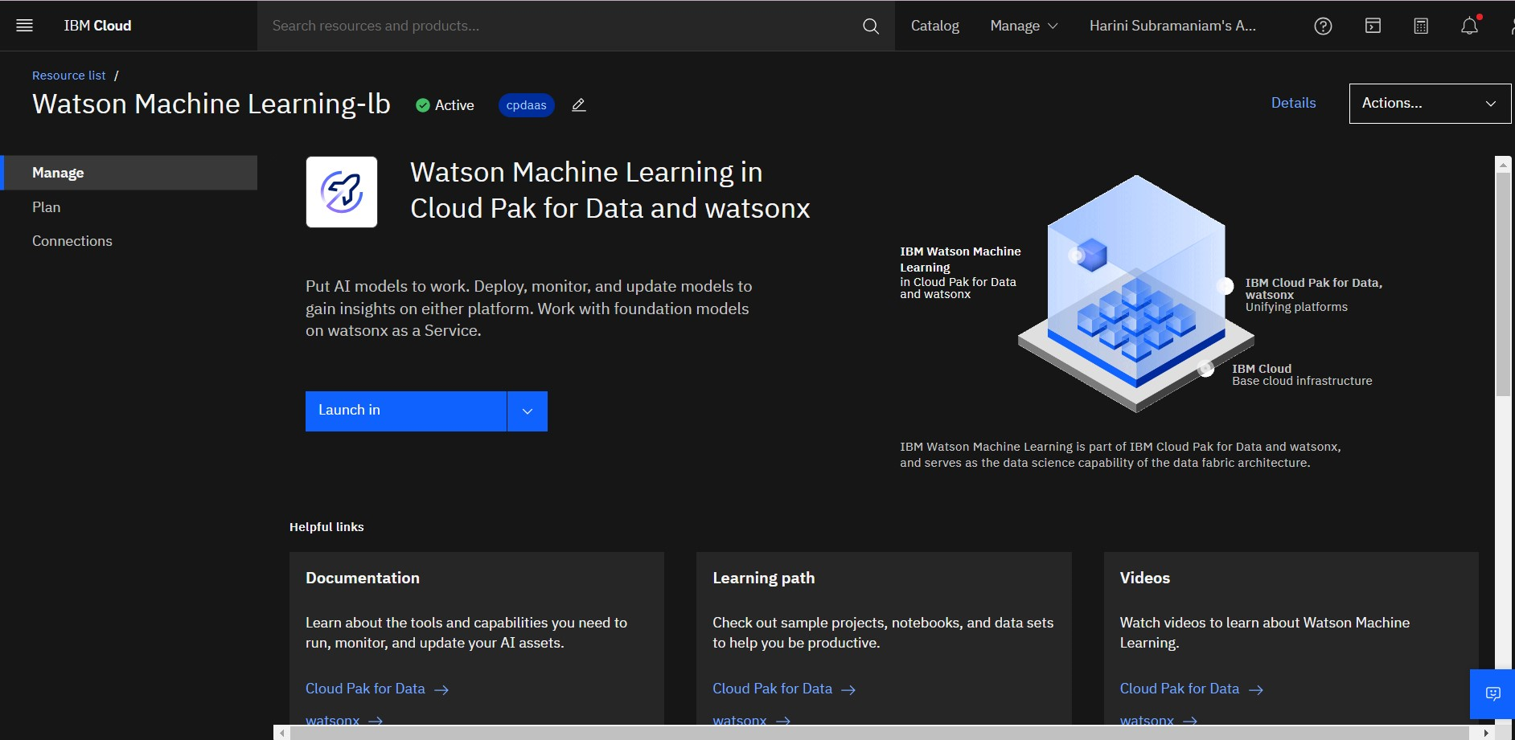

**5.3 Code for the project:**

Deriving of a code and analysing in the context of data security and privacy in big data analysis involves examining and understanding datasets while adhering to stringent security and privacy measures.

**Dataset Selected from the IBM Cloud for the analysis:**

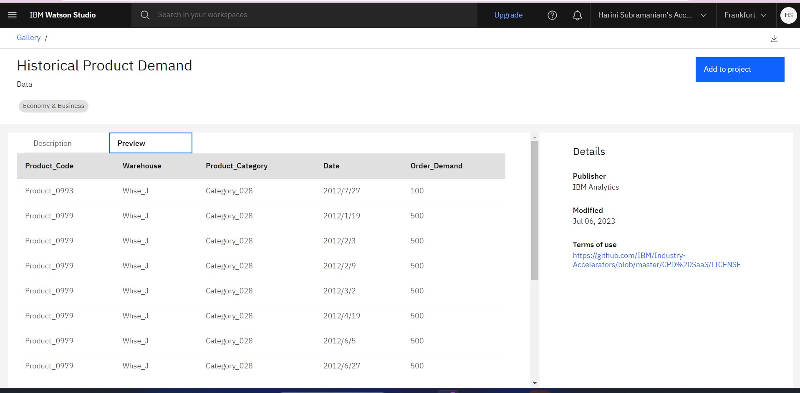

**Visualizing the Selected Dataset:**

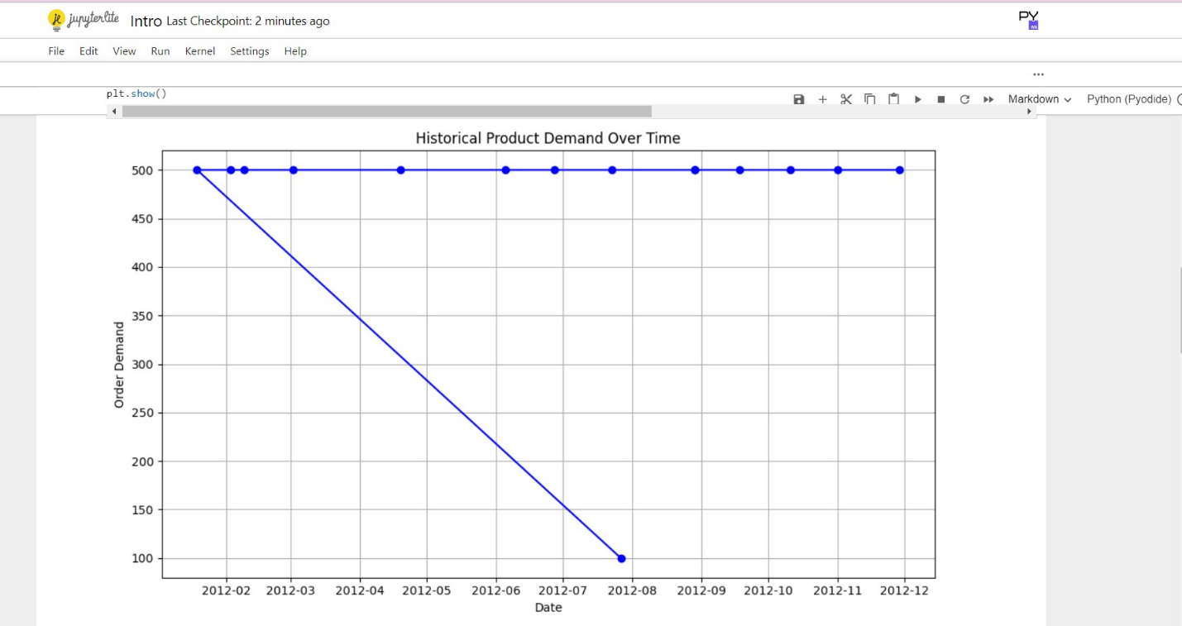

**Python code for Big Data Analysis based on Data security and Privacy:**

Import pandas as pd

# Load your dataset (replace 'your_dataset.csv' with your actual dataset file)

Df = pd.read_csv('/content/Historical_Product_Demand.csv')

# Display basic information about the dataset

Print("Dataset Information:")

Print(df.info())

# Check for missing values

Missing_values = df.isnull().sum()

Print("\nmissing Values:")

Print(missing_values)

# Identify unique values in each column

Unique_values = {column: df[column].unique() for column in df.columns}

Print("\nunique Values:")

Print(unique_values)

# Statistical summary of numerical columns

Numerical_summary = df.describe()

Print("\nnumerical Summary:")

Print(numerical_summary)

# Analyze data distribution for categorical columns

Categorical_columns = df.select_dtypes(include='object').columns

For column in categorical_columns:

Print(f"\ndistribution for {column}:")

Print(df[column].value_counts())

# Explore data patterns, correlations, or anomalies as needed

# Define terms based on the analysis

Data_security_definition = """

Data security refers to the implementation of measures and safeguards to protect data from unauthorized access, disclosure, alteration, or destruction. In this dataset, potential security concerns may include the presence of sensitive information and the need for encryption or access controls.

"""

Data_privacy_definition = """Data privacy involves ensuring that individuals' personal information is handled with confidentiality and respect. In this dataset, privacy considerations may involve identifying and anonymizing personally identifiable information (PII) to prevent unauthorized identification of individuals.

"""

Print("\ndefined Terms:")

Print("Data Security:", data_security_definition)

Print("\ndata Privacy:", data_privacy_definition)

**Work flow of python code:**

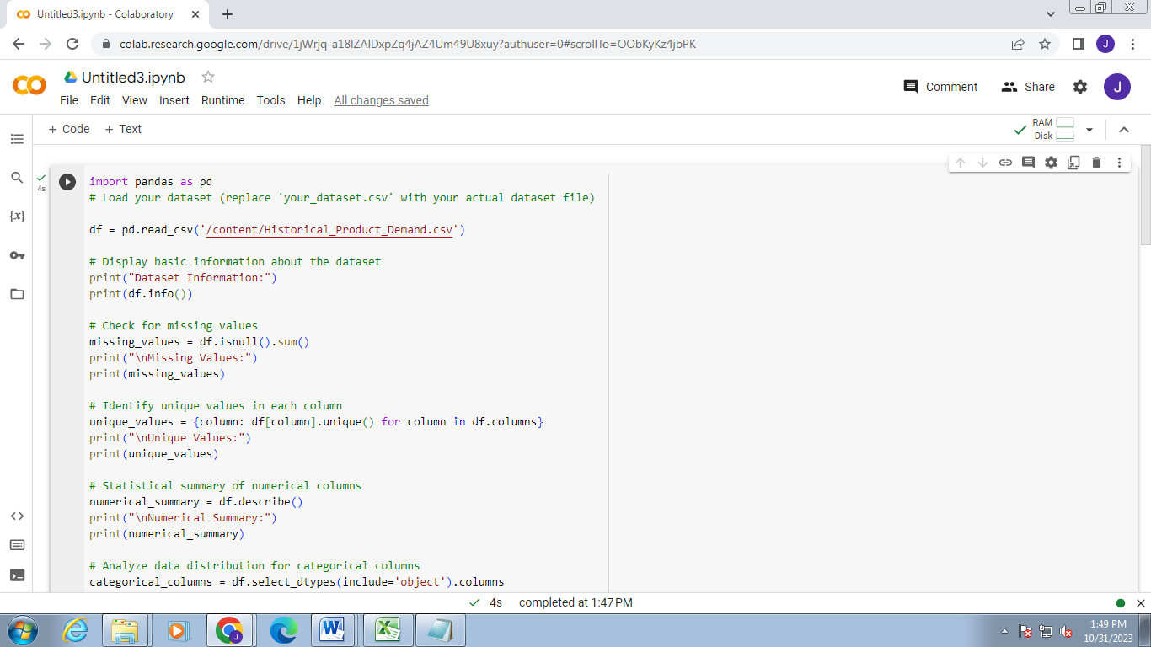

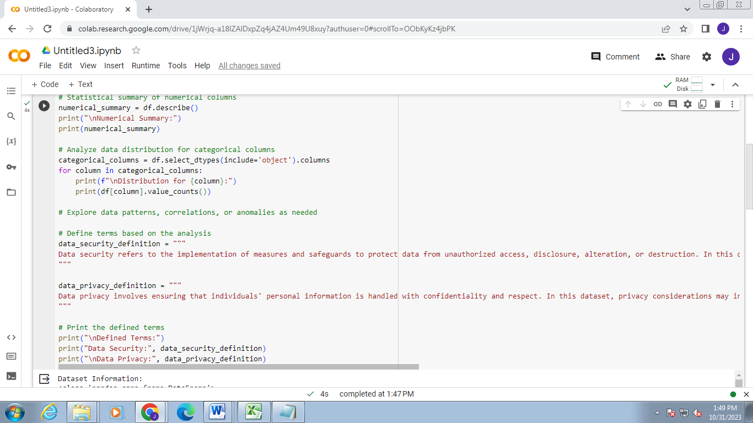

**Output of the code:**

Analysis based on the data security and privacy

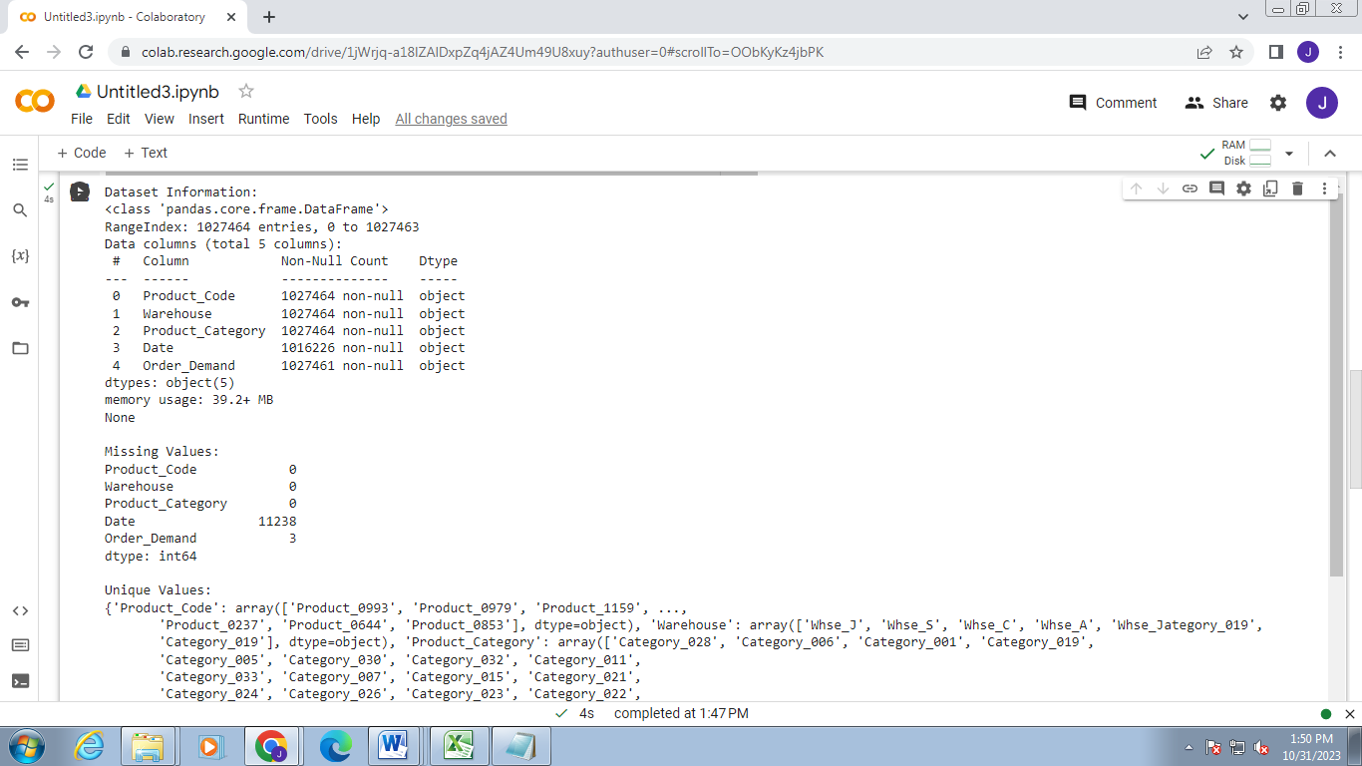

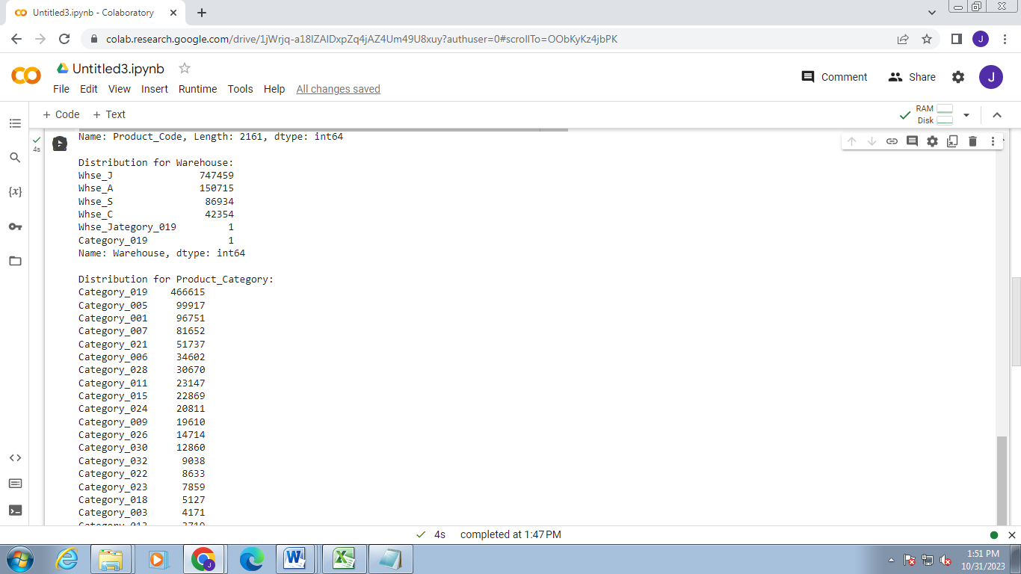

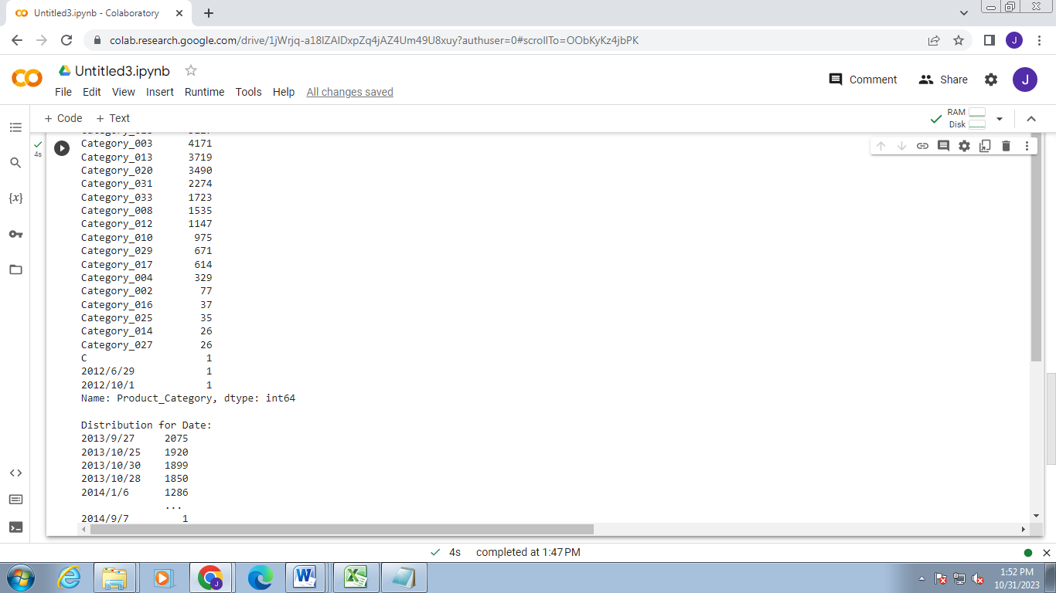

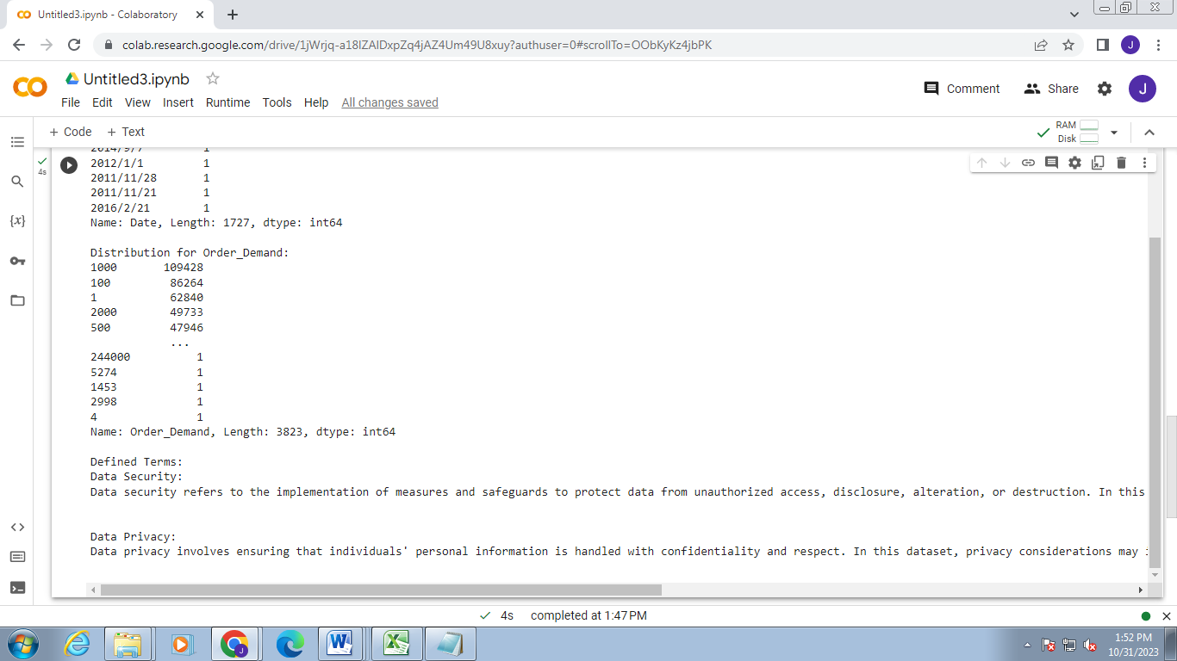

**Conclusion:**

The project has successfully demonstrated the feasibility of conducting robust big data analysis while prioritizing data security and privacy. The methodologies and solutions implemented are poised to serve as a foundation for future initiatives, providing a blueprint for organizations aiming to navigate the intricate landscape of big data analytics securely. The collaboration with IBM Cloud services has proven instrumental in achieving the project's objectives, and the insights gained pave the way for further advancements in the intersection of data analytics, security, and privacy**.**